**DB2 10.5 Upgrade Runbook**

This document outlines the DB2 V10.1 upgrade to DB2 V10.5:

IBM Upgrade Documentation Link:

<http://www-01.ibm.com/support/knowledgecenter/SSEPGG_10.5.0/com.ibm.db2.luw.qb.upgrade.doc/doc/t0007187.html>

1. Backup the existing databases
2. 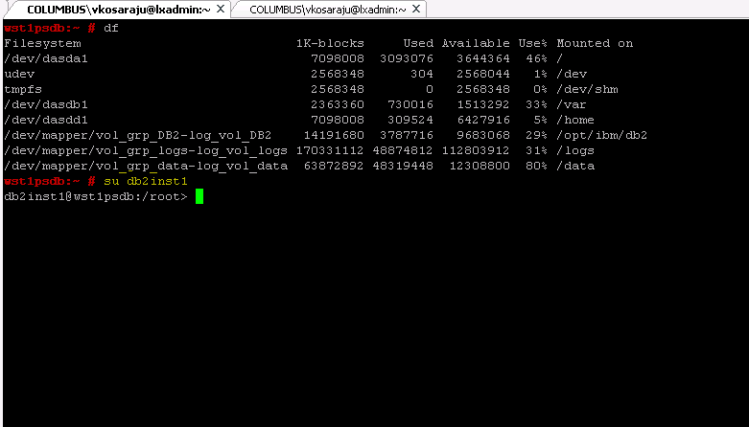
3. 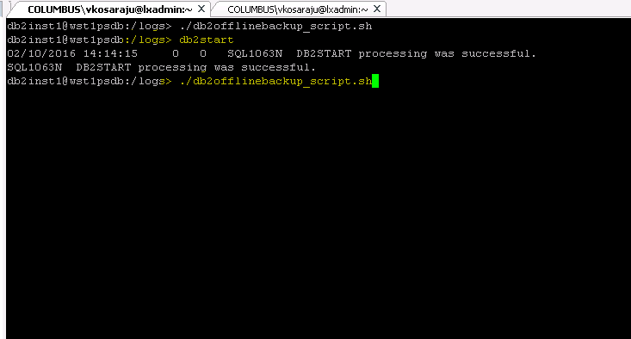

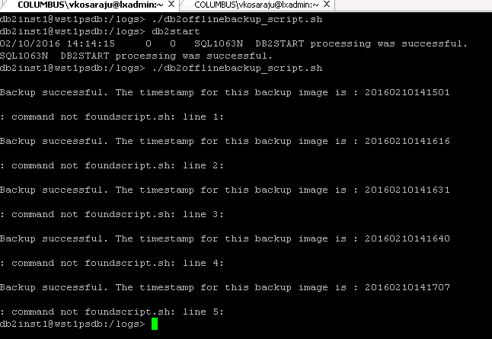

Execute the DB2 CheckUpgrade command

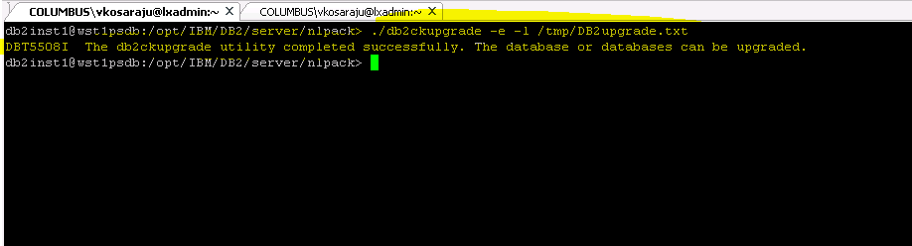

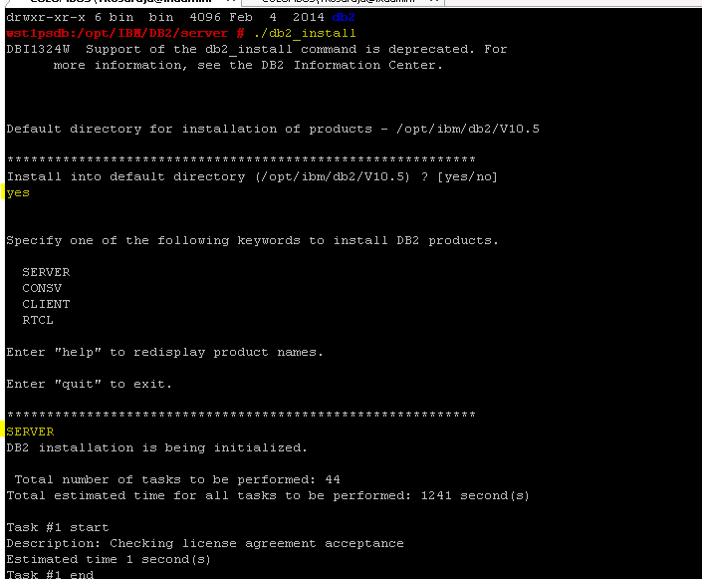

DB2 instance Upgrade after installing the Binaries:

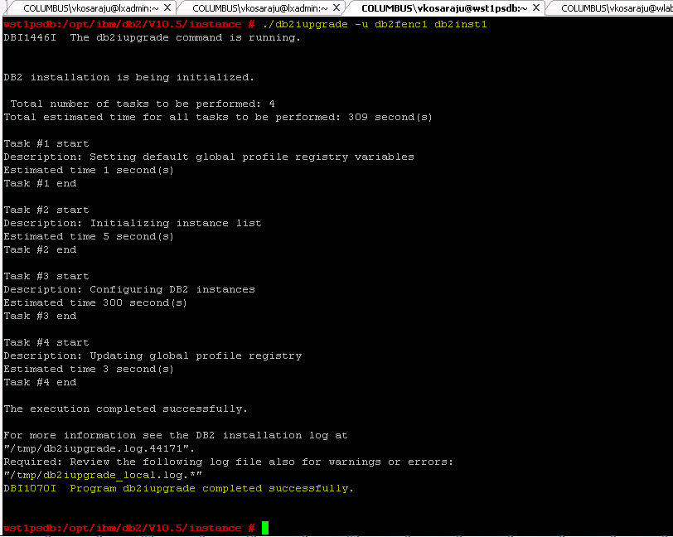

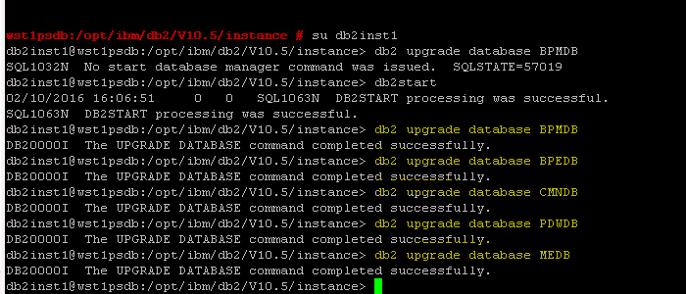

DB2 Offline backups(Post Upgrade):

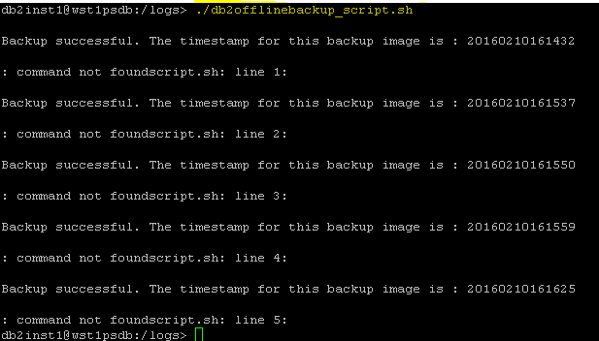

Please come back to this below step after completing the BPM profile and DBUpgrade tasks.

Create Indexs to resolve the post profile upgrade start-up issues:

CREATE INDEX DB2INST1.LSWC_UXREF_TEMP ON DB2INST1.LSW_USR_XREF (UPPER(USER_NAME) ASC, USER_ID, FULL_NAME, PROVIDER) MINPCTUSED 0 ALLOW REVERSE SCANS PAGE SPLIT SYMMETRIC COLLECT STATISTICS;

**DROP** **INDEX** DB2INST1.LSWC_UXREF_UQ2;

**CREATE** **UNIQUE** **INDEX** DB2INST1.LSWC_UXREF_UQ2 **ON** DB2INST1.LSW_USR_XREF ( USER_ID, USER_NAME ) INCLUDE ( FULL_NAME, PROVIDER ) ALLOW REVERSE SCANS **PAGE** SPLIT SYMMETRIC COMPRESS **NO**;

**CALL** SYSPROC.REBIND_ROUTINE_PACKAGE ( 'P', 'DB2INST1.LSW_TASK_CLOSE', 'RESOLVE ANY' );

**CALL** SYSPROC.ADMIN_CMD( 'RUNSTATS ON TABLE DB2INST1.LSW_USR_XREF FOR INDEX DB2INST1.LSWC_UXREF_UQ2' );

Reorg and Runstats of the entire system

